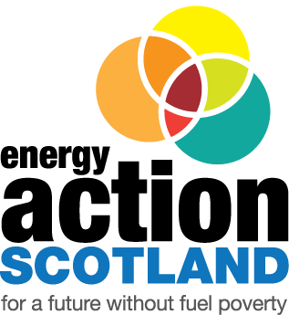

Energy Action Scotland
WGF Fuel Poverty Challenge Fund

application form
Before filling in this form, please read the Guidance Notes. Please note that the organisation applying must be an Ordinary or Campaigning member of Energy Action Scotland. The proposed project must be in Scotland.
If you have any questions in relation to your proposal, please email these to fuelpovertychallengefund@eas.org.uk
Deadline for receipt of applications is 5.00pm on Friday 30 September 2022.

Contact details
Organisation details
Name of organisation
Address
Contact name
EAS membership status
Telephone
Email address

OFFICE USE ONLY
Date Received |  | Application No.
Approved Y/N |  | £ Requested

Date Notified

Your project proposal
Project summary
Please provide a summary of your proposed project including what you want to achieve in its delivery. Please include a brief explanation of why the project is needed and how you know this.

Approach
What is your approach? What methods of engagement or other means do you intend to use in your project?

Beneficiaries and outcomes
Who will benefit from this project and how e.g. reduced fuel bills, increased knowledge/ understanding/ confidence, improved comfort/health/wellbeing, etc?

People/Places/Properties
How many people/households will be targeted/involved? Where are they located? While we look to see value for money please note you will not be judged on the volume of beneficiaries alone.

Timescale
When/over what period will the project be delivered? Please list the main project milestones and timeline.

Monitoring and evaluation
What specific outputs do you expect to achieve with your project? How will you monitor the outcomes and evaluate them? Please specify how information will be collected.

Finance
Other details that you think will support your application
Please provide any other information about the project and why you feel it deserves support from the WGF Fuel Poverty Challenge Fund.

Please note that a condition of the grant award is the submission of an end of project report. All awards will be subject to a retention fee of 10% which will be released upon the delivery of a satisfactory end-of-project report. All projects receiving funding are expected to take part in any publicity that EAS or the William Grant Foundation wish to generate around the Fund.

Please return this form by 5.00pm on Friday 30 September 2022 to:
fuelpovertychallengefund@eas.org.uk

